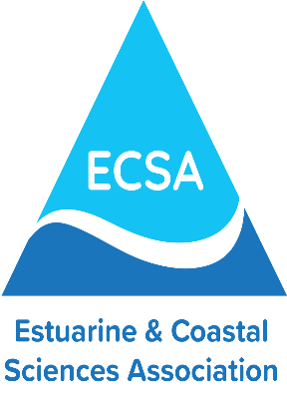

Grants to support members’ and student members’ attendance at ECSA59

Applications are invited from members of ECSA for grants to support their attendance at the conference ECSA59 from the 5-8th September 2022. Two types of grants are available:
- Up to £500 sterling is available to support members’ registration fees and travel to enable students from any country and scientists from DAC countries to attend this conference and make a presentation.
- In addition, for ECSA members who have particular needs such as child care responsibilities, or that require the support of a carer to enable them to attend the meeting, up to £200 sterling is available to enable them to attend the meeting and make an oral or poster presentation. This grant may be used in a variety of ways, for example, to cover additional child care costs incurred during the conference.
Applicants must be a member of ECSA and have submitted an abstract for an oral or poster presentation at the conference. Funds will be made available on presentation of receipts after attendance at the conference. Applications should be made on the ECSA59 travel grant form, which is available through the ECSA website, and submitted to Dr Gillian Glegg (gglegg@plymouth.ac.uk) by the 31st May 2022. Successful candidates will be informed by 10th June 2022.

